TABLES:

15.MANAGER:

CREATE TABLE MANAGER (

M_ID NUMBER (5,0) PRIMARY KEY,

M_NAME VARCHAR2 (500) NOT NULL,

M_AGE INT,

SALARY INT,

REG_NO NUMBER (6,0),

ADD_ID NUMBER (3,0) NOT NULL,

PHONE_ID NUMBER (4,0) UNIQUE,

FOREIGN KEY (REG_NO) REFERENCES ORPHANGE (REG_NO),

FOREIGN KEY (ADD_ID) REFERENCES ADDRESS (ADD_ID),

FOREIGN KEY (PHONE_ID) REFERENCES PHONES (PHONE_ID)

)

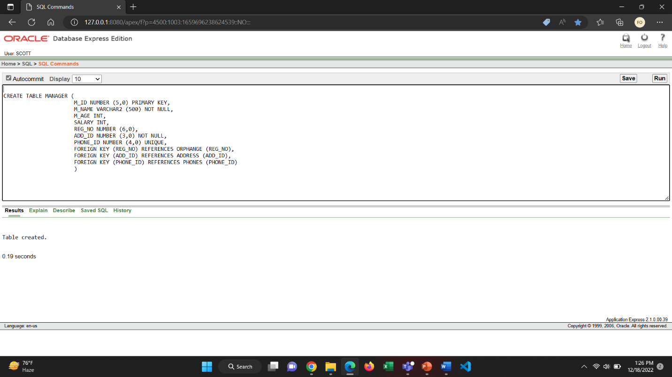

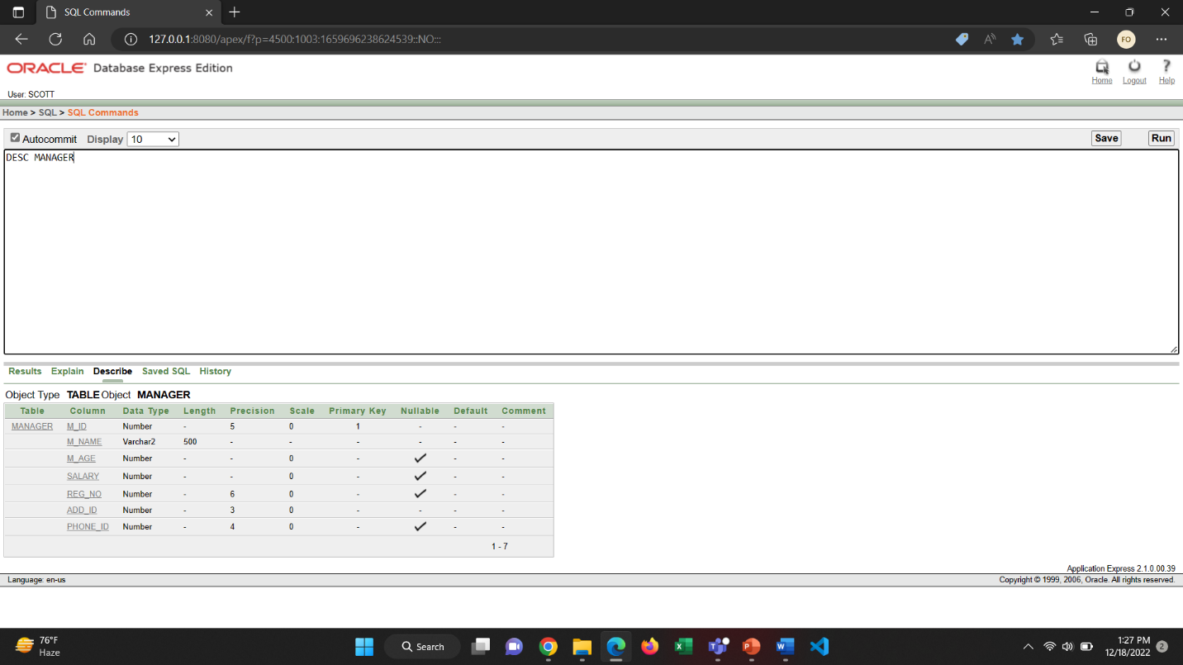

8.O_COLLECTOR

CREATE TABLE O_COLLECTOR (

C_ID NUMBER (6,0) PRIMARY KEY,

C_NAME VARCHAR2 (300) NOT NULL,

TOTAL_COLLECTION INT,

SALARY INT,

C_AGE NUMBER (3),

M_ID NUMBER (5,0),

PHONE_ID NUMBER (4,0) UNIQUE,

FOREIGN KEY (M_ID) REFERENCES MANAGER (M_ID),

FOREIGN KEY (PHONE_ID) REFERENCES PHONES (PHONE_ID)

)

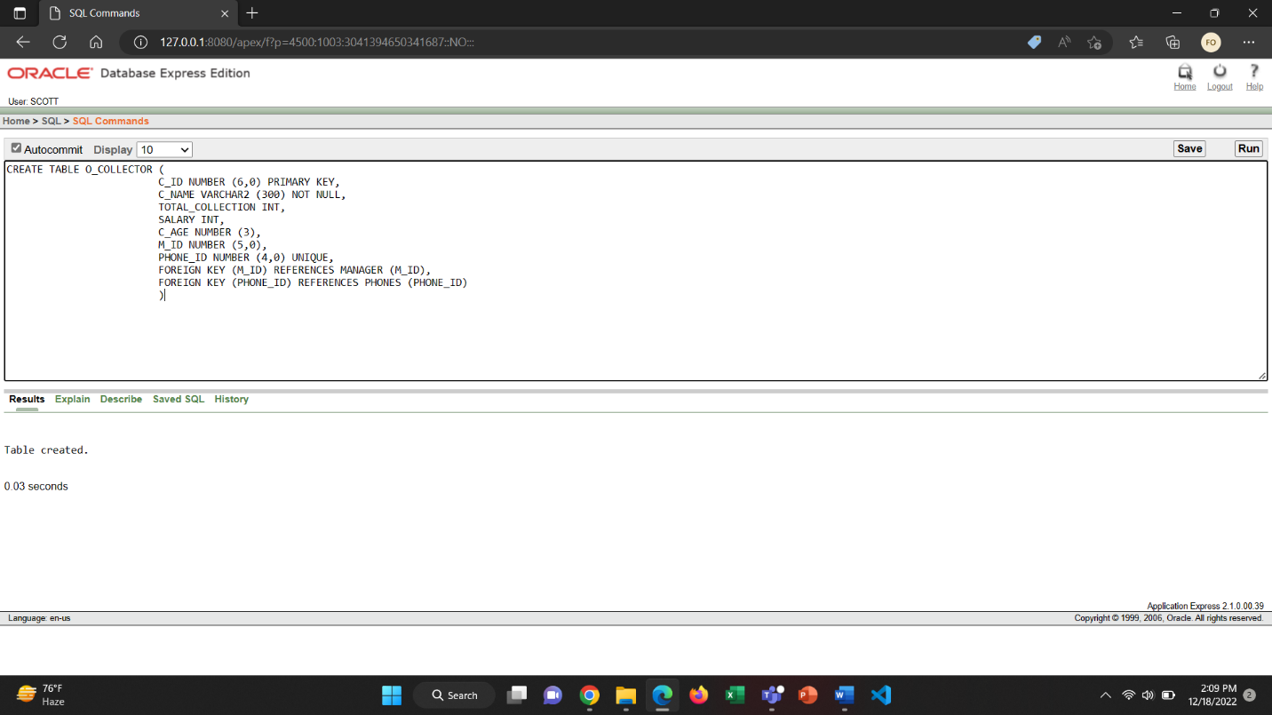

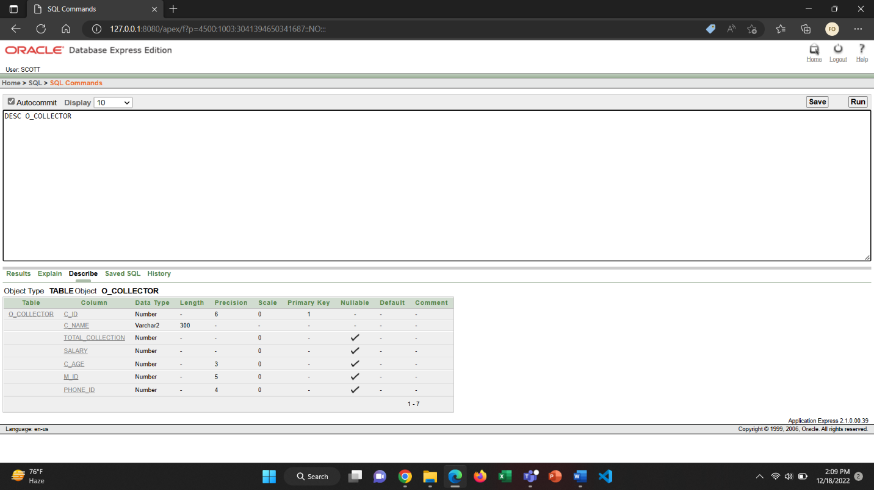

9.ADOPTER

CREATE TABLE ADOPTER (

A_ID NUMBER (6) PRIMARY KEY,

A_NAME VARCHAR2 (300) NOT NULL,

A_AGE NUMBER (3) CHECK (A_AGE>18),

NID_NO VARCHAR2 (300) NOT NULL,

EMAIL VARCHAR2 (300) NOT NULL,

FINANCIAL_CONDITION INT CHECK (FINANCIAL_CONDITION>=100000),

ADOPTION_DATE DATE CHECK (ADOPTION_DATE>='01-JAN-2122'),

ADD_ID NUMBER (3,0) NOT NULL,

PHONE_ID NUMBER (4,0) UNIQUE,

FOREIGN KEY (ADD_ID) REFERENCES ADDRESS (ADD_ID),

FOREIGN KEY (PHONE_ID) REFERENCES PHONES (PHONE_ID)

)

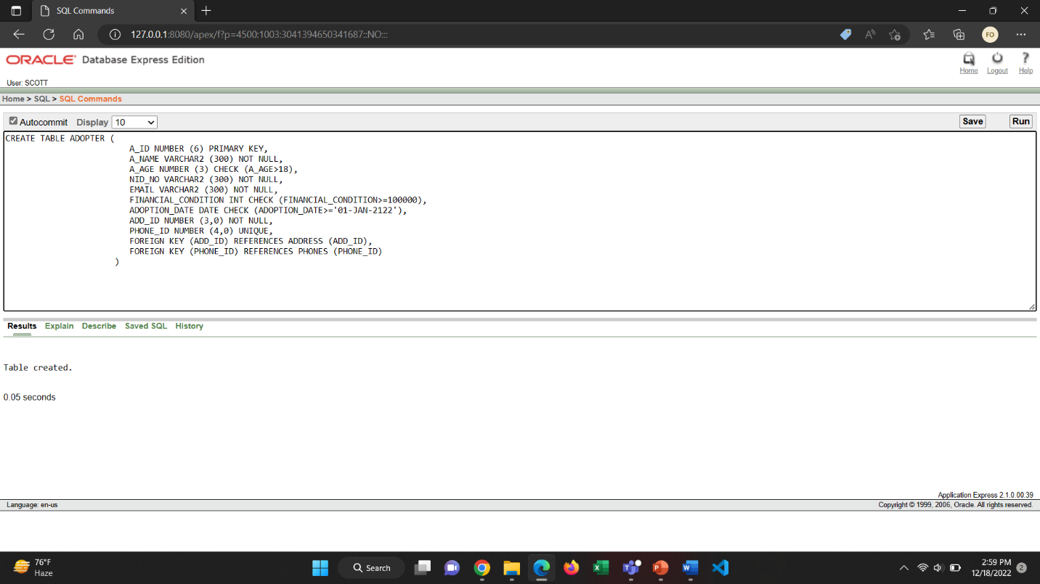

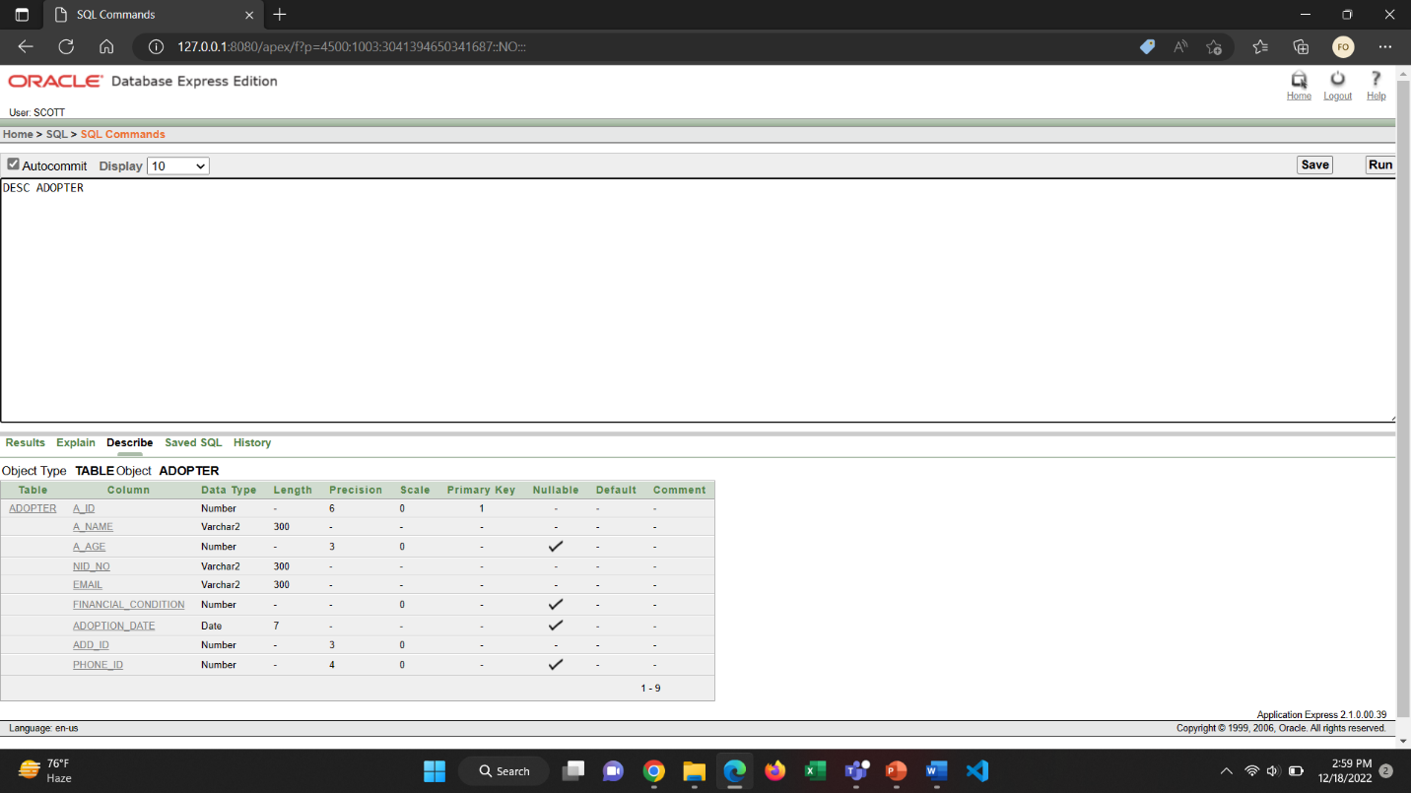

10. TEACHER

CREATE TABLE TEACHER (

T_ID NUMBER (6) PRIMARY KEY,

T_NAME VARCHAR2 (300) NOT NULL,

SUBJECT VARCHAR2 (300) NOT NULL,

JOIN_DATE DATE CHECK (JOIN_DATE>='01-JAN-2122'),

EIIN_NO NUMBER (6),

ADD_ID NUMBER (3,0) NOT NULL,

PHONE_ID NUMBER (4,0) UNIQUE,

FOREIGN KEY (ADD_ID) REFERENCES ADDRESS (ADD_ID),

FOREIGN KEY (PHONE_ID) REFERENCES PHONES (PHONE_ID)

)

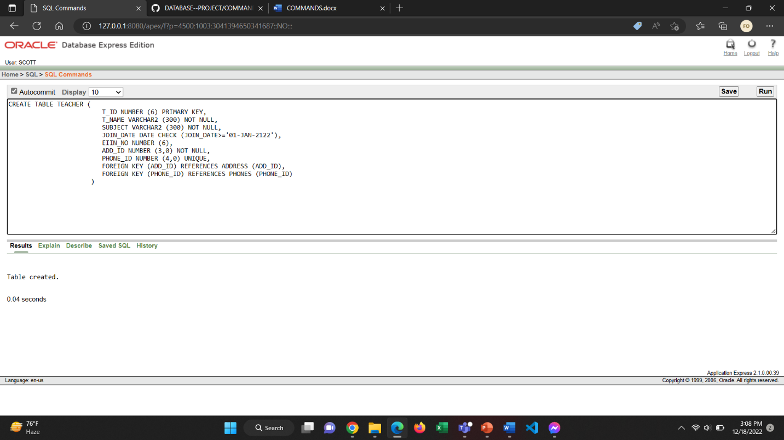

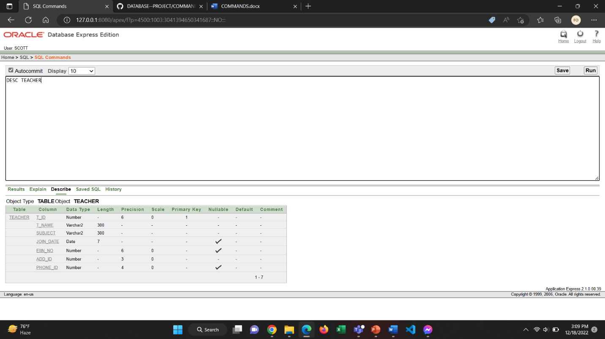

11.STAFF

CREATE TABLE STAFF (

S_ID NUMBER (6) PRIMARY KEY,

S_NAME VARCHAR2 (300) NOT NULL,

S_AGE NUMBER (3),

JOIN_DATE DATE CHECK (JOIN_DATE>='01-JAN-2122'),

M_ID NUMBER (5,0),

ADD_ID NUMBER (3,0) NOT NULL,

PHONE_ID NUMBER (4,0) UNIQUE,

FOREIGN KEY (M_ID) REFERENCES MANAGER (M_ID),

FOREIGN KEY (ADD_ID) REFERENCES ADDRESS (ADD_ID),

FOREIGN KEY (PHONE_ID) REFERENCES PHONES (PHONE_ID)

)

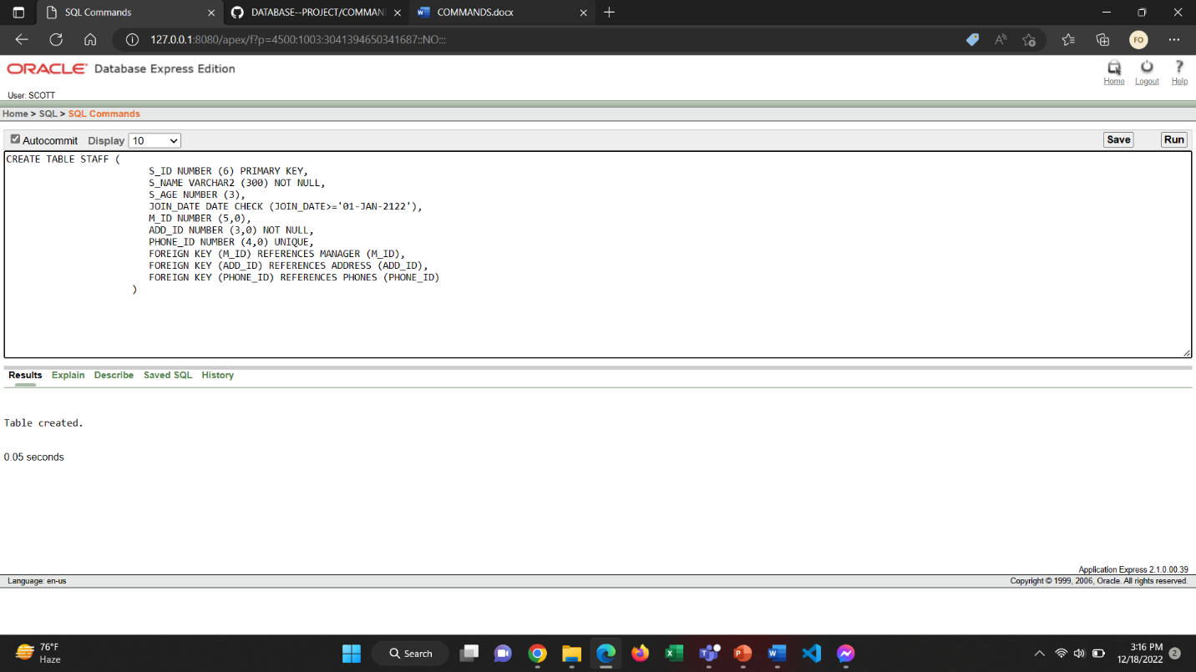

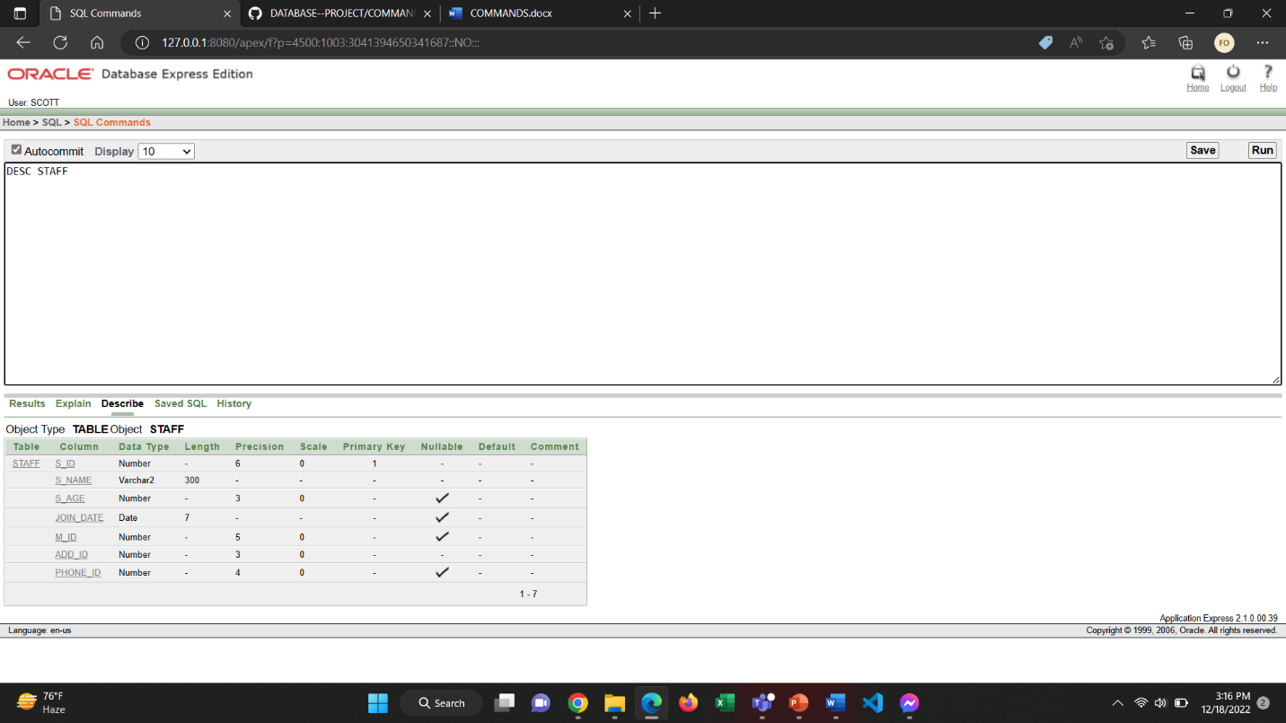

CREATE TABLE STAFFINFO(

S_ID NUMBER(6) UNIQUE,

S_POSITION VARCHAR2(255) DEFAULT 'JUNIOR STAFF',

SALARY NUMBER(8,3) NOT NULL,

FOREIGN KEY(S_ID) REFERENCES STAFF(S_ID)

);

DESC STAFFINFO;

CREATE TABLE ORPHAN(

O_ID NUMBER(3) PRIMARY KEY,

O_NAME VARCHAR2(255) NOT NULL,

B_GROUP VARCHAR2(255) CHECK(B_GROUP IN('A+','B+','A-','B-','AB+','AB-','O+','O-')),

GENDER VARCHAR2(255) CHECK(GENDER IN('MALE','FEMALE','OTHER')),

O_AGE NUMBER(2) NOT NULL,

REG_NO NUMBER(6,0) NOT NULL,C_ID NUMBER(6,0) NOT NULL,DOC_ID NUMBER(5,0) NOT NULL,

A_ID NUMBER(6,0) NOT NULL,T_ID NUMBER(5,0) NOT NULL,S_ID NUMBER(6,0) NOT NULL,

FOREIGN KEY (REG_NO) REFERENCES ORPHANGE (REG_NO),FOREIGN KEY (C_ID) REFERENCES O_COLLECTOR (C_ID),FOREIGN KEY (DOC_ID) REFERENCES DOCTOR (DOC_ID),

FOREIGN KEY (A_ID) REFERENCES ADOPTER (A_ID),FOREIGN KEY (T_ID) REFERENCES TEACHER (T_ID),FOREIGN KEY (S_ID) REFERENCES STAFF (S_ID)

);

DESC ORPHAN

CREATE TABLE ORPHANINFO(

O_ID NUMBER(3) UNIQUE,

C_DATE DATE CHECK(C_DATE>='01-JAN-2122'),

COLLECTED_FROM VARCHAR2(255) NOT NULL,

COLLECTOR VARCHAR2(255) NOT NULL,

FOREIGN KEY (O_ID) REFERENCES ORPHAN (O_ID)

);

DESC ORPHANINFO;

INSERT INTO SCHOOL

VALUES (654321, 'SUNSHINE ORPHANGE SCHOOL', DEFAULT)